Name:____________________ Block:_____
Mind Map
The First Nations and Metis traders used maps they created from memory. These maps were used to help them, and others, return to good hunting ground, sources of water, or grass for their animals. These maps helped open up the northwest for eventual settlement.
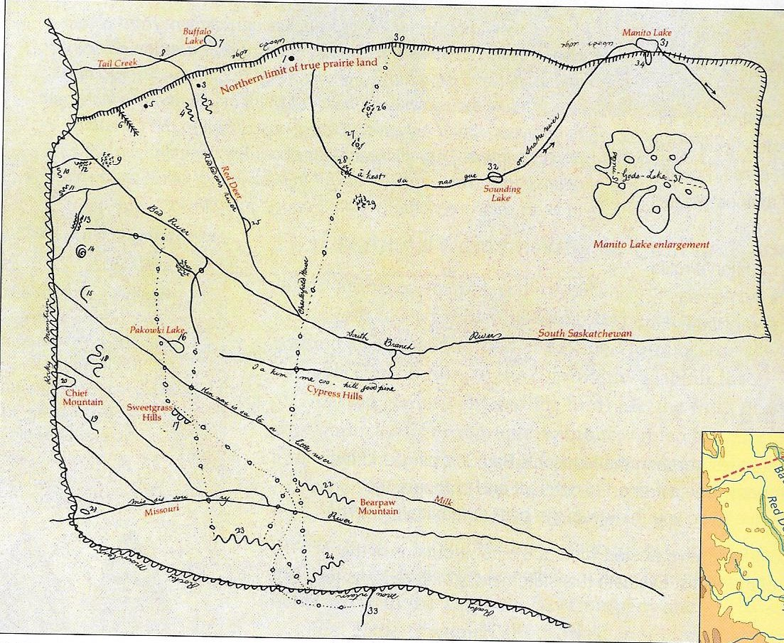
Use your memory to create your own mind map of the area near your home and school. Include these key locations:
Your house(s) | Your school | Main roads | Friends homes
Recreation spots | Places you hang out | Where you work | Places where you shop, buy food etc.
Parks you visit | Bus stops if you take the bus | Important places in the town | Other important places for you
Draw it from memory on one sheet of paper.
Label the important places.

