Name: ________________________________ Block: _________
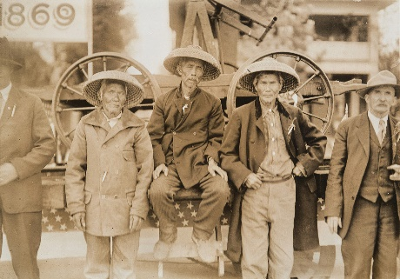
A Day in the Life: Chinese Railway Workers
Write a diary entry as if you are one of the Chinese railway workers working on the railway in British Columbia. Be sure to include the tone of the setting and the events surrounding the construction of the railway. Feel free to get creative. At least 1 page, single spaced. (Pages 194-201; 235)

