Strength & Conditioning 10 / EliteADP Final Presentation
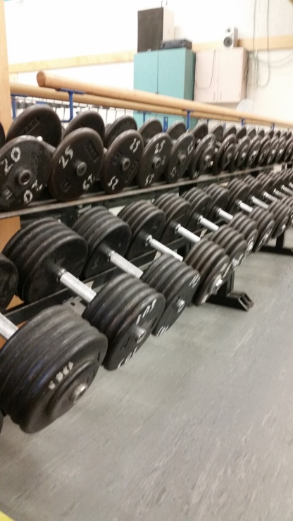
Your goal for the project/presentation is to reflect on the course and yourself throughout the year.
You will be presenting your findings and evidence through some sort of presentation (ie. PowerPoint, Prezi, etc.). Be sure to include visuals in your presentation.
Complete the following sections in your presentation:
Section 1: Then and Now
- Why did you decide to take this course?
- What goals did you set for yourself at the start of the year? Did you meet your goals? Why do you think you did or did not meet your goals (what helped/held you back)?
- What were your personal fitness strengths and weaknesses at the start of the year? What are they now? Why do you think they did or did not change?
Section 2: Fitness Testing
- For each of the five different tests (S&C10: bench reps, push ups, pull ups, plank, 12 min run / EliteADP: bench max, pull ups, plank, vertical jump, 12 min run) make a CHART or a GRAPH showing how you did.
- For each of the tests, answer the following:
  - Did you improve as the year went on? Why or why not? What helped you beat your old score (hard work, working out outside of school, etc.) or what prevented you from beating it (poor nutrition, lack of working out, etc.)?
  - Are you happy with your results?
Section 3: Somatotypes
- What is a somatotype? What are the three different somatotypes?
- Visit https://www.bodybuilding.com/fun/becker3.htm and determine what your somatotype is.
- What sports fit your somatotype? Do you play any of those sports? Is your body made for the sport/activity of your choice?

Section 4: Future
- What are your future plans for remaining active? During the summer? After high school?
- Are your future plans attainable with the resources available to you?
- What resources are available to you outside of those at the school?
Section 5: Personal Evaluation
- Looking back on the year, did you come to class every day ready to work or did you come to class not wanting to do any work?
- List THREE of your strengths in the class (attendance, hard work, helping others, etc.)
- List THREE of your weaknesses in the class (lazy, can’t listen to instructions, bad attitude/language)
Section 6: Course Evaluation
- What did you like about the course?
- Did you get what you wanted out of the course?
- What did you not like about the course?
- If you could change anything from the course, what would it be?

